# GLOBAL WEATHER APP

VERSION 1

| REVISION HISTORY | | | |
| --- | --- | --- | --- |
| DATE | Comments | version | AUTHOR |
| Jun28, 2021 | Initial Document | 1.0 | Mounika Gaddam |
|  |  |  |  |

# Introduction

The document is intended to provide all the required information to access/consume the globalweatherapp REST API.

# Technical Assumptions

The project is built using Mule 4 and might not be executable on earlier versions.

The Webservice is exposed via localhost:8080 using node as runtime.

The REST API is exposed over localhost:8081 i.e, the default mule listener.

# Resources

The globalweatherapp exposes the following resources

1. /countries
2. /countries/(country)/cities
3. /countries/(country)/cities/(city)/weather

All the 3 resources are implemented using GET method.

# Backend Details:

The REST service access all the information from global-weather webservice which follows the wsdlglobal-weather.wsdl.

Wsdl location is <http://localhost:8080/GlobalWeather?wsdl>

## Architecture Diagram

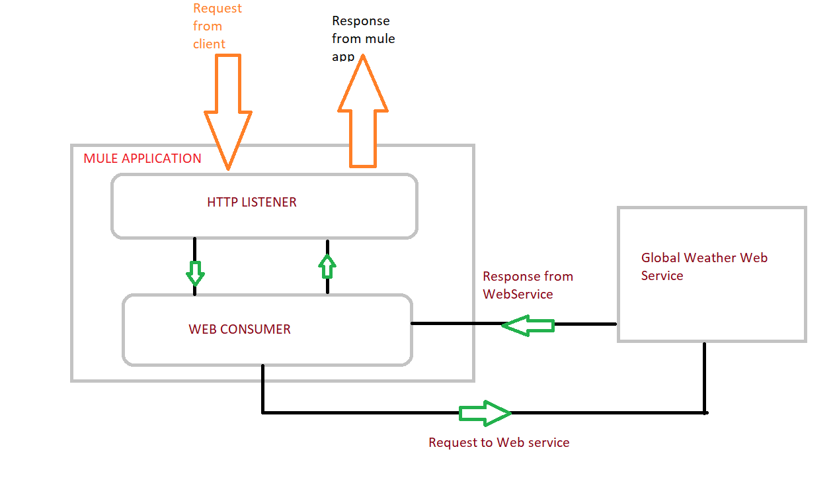

# Technical Details

In this section let us look in detail about all the resources and how to consume them

## /countries:

This is a GET resource which provides all the countries supported by the weather app.

**Sample Response**

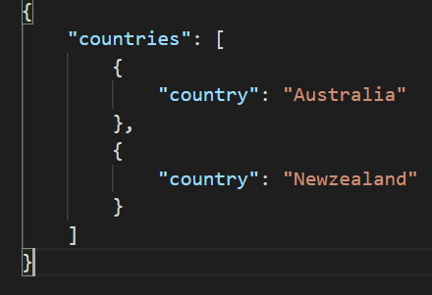

## /countries/(country)/cities

This is a GET resource which provides all the cities supported by the weather app for the country that is requested.

Requires {country} to be passed as a path parameter

**Sample Response**:

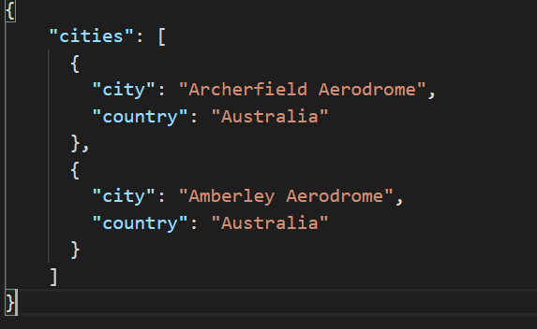

## /countries/(country)/cities/(city)/weather

This is a GET resource which provides the weather for the country and city combination that is requested.

Requires {country} to be passed as a path parameter

Requires {city} to be passed as a path parameter

**Sample response:**

